West Virginia
ARIMA (0,1,3) (0,1,1)
Parameter | Estimate | Std. Error | t-statistic | p-value
θ₁ | -0.952 | 0.0542 | -17.58 | <.0001
θ₂ | 0.239 | 0.073 | 3.26 | 0.0011
θ₃ | -0.147 | 0.054 | -2.72 | 0.0065
Θ₁ | -0.797 | 0.038 | -21.21 | <.0001
β | 0.704 | 0.083 | 8.48 | <.0001
ω₁ | 0.366 | 0.069 | 5.31 | <.0001
υ₁ | 0.325 | 0.085 | 3.84 | 0.0001
υ₁₁ | 0.497 | 0.081 | 6.10 | <.0001
δ₁ | 0.745 | 0.073 | 10.23 | <.0001

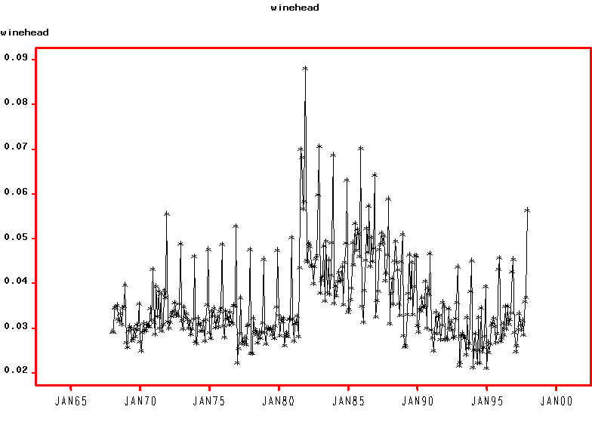

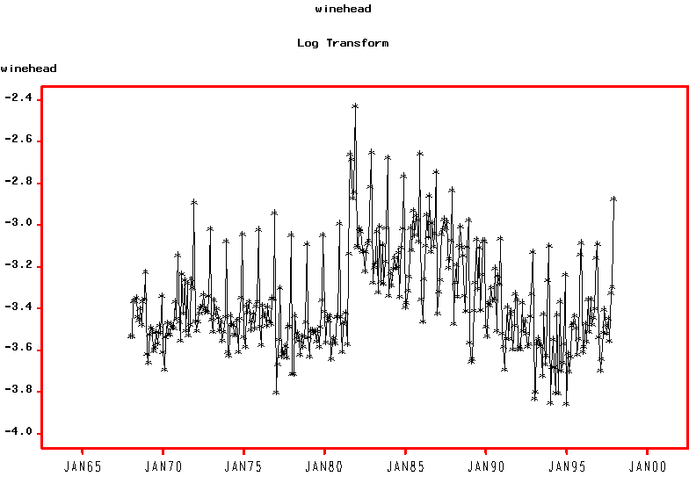
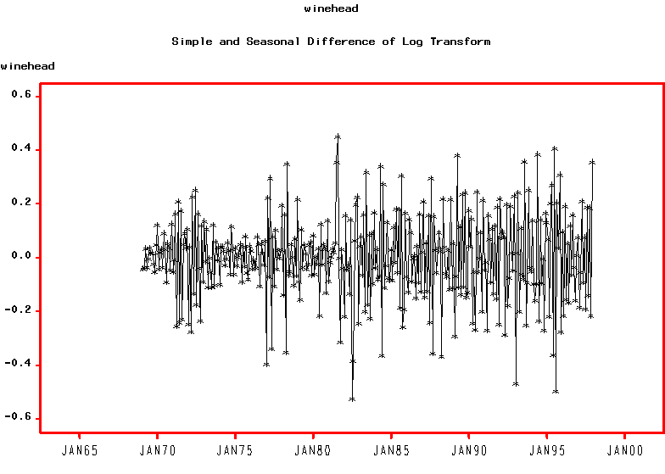
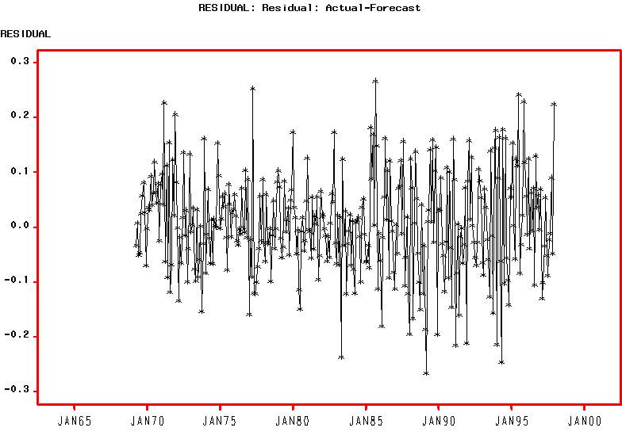
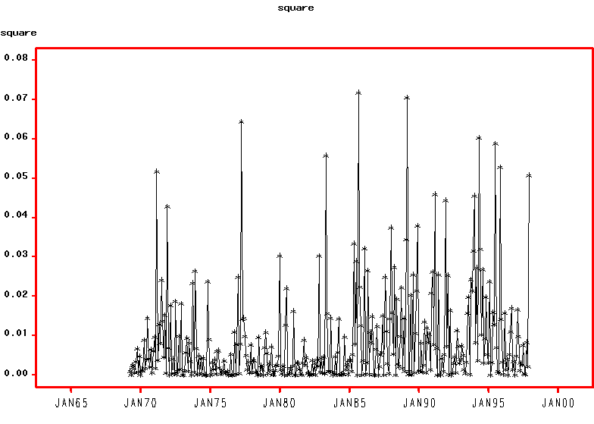

GARCH (1,1)
Value Std.Error t value Pr(>|t|)
MA(1) -0.9414076 0.005820 -161.758 0.000e+000
MA(2) 0.2277164 0.031514 7.226 1.693e-012
MA(3) -0.1758357 0.035422 -4.964 5.507e-007
MA(4) 0.0000000 NA NA NA
MA(5) 0.0000000 NA NA NA
MA(6) 0.0000000 NA NA NA
MA(7) 0.0000000 NA NA NA
MA(8) 0.0000000 NA NA NA
MA(9) 0.0000000 NA NA NA
MA(10) 0.0000000 NA NA NA
MA(11) 0.0000000 NA NA NA
MA(12) -0.7045853 0.029061 -24.245 0.000e+000
MA(13) 0.6305444 0.015901 39.655 0.000e+000
MA(14) -0.0938246 0.033830 -2.773 2.929e-003
xwine.s1 0.3442752 0.074076 4.648 2.418e-006
xwine.fp1 0.5330049 0.090523 5.888 4.749e-009
xwine.ctrl 0.5746637 0.059971 9.582 0.000e+000
A 0.0009076 0.000491 1.849 3.270e-002
ARCH(1) 0.1967666 0.084934 2.317 1.056e-002
GARCH(1) 0.7035333 0.120433 5.842 6.118e-009

--------------------------------------------------------------

AIC(20) = -670.8371
BIC(20) = -593.8506

Normality Test:
--------------------------------------------------------------
Jarque-Bera P-value Shapiro-Wilk P-value
2.7 0.2592 0.979 0.1065

Ljung-Box test for standardized residuals:
--------------------------------------------------------------
Statistic P-value Chi^2-d.f.
14.9 0.2469 12

Ljung-Box test for squared standardized residuals:
--------------------------------------------------------------
Statistic P-value Chi^2-d.f.
7.191 0.8447 12

